Feb 20, 2022

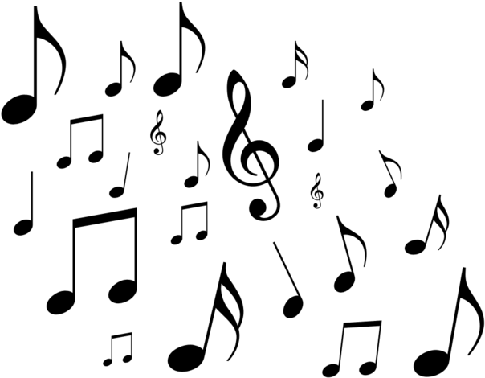

OFFICIAL USER MANUAL

EECS2311 SOFTWARE DEVELOPMENT PROJECT

GROUP 1:

Abdelrahman Altamimi

Hieu Le

Mahdiar Shoraka

Prabjot Dhaliwal

Yongjie Ba

**Table of Contents**

**Table of Contents …………………………………………………………………………..2**

1. **About TAB2XML and Intend Use……….…..…………………………………3**
2. **System Requirements………………………………….………………………..…3**
3. **Installing TAB2XML using Gradle…………………………………………….4**
4. **How to use TAB2XML…………………………………………………………….8**
   1. **Preview Sheet Music**……………………………………………….**9**
   2. **Music Playback**…………………………………………………….**9**
5. **Input Requirement………………………………………………………………..10**
6. **About TAB2XML and Intended Use:**

TAB2XML is a software tool used to convert text-based tablature files to MusicXML files with its corresponding visual representation in downloadable sheet music, and playable audio of the music itself. The MusicXML file can be easily used by many other music programs due to its high compatibility. The visual sheet music feature is currently supported for Guitar, Bass and Drums tablatures.

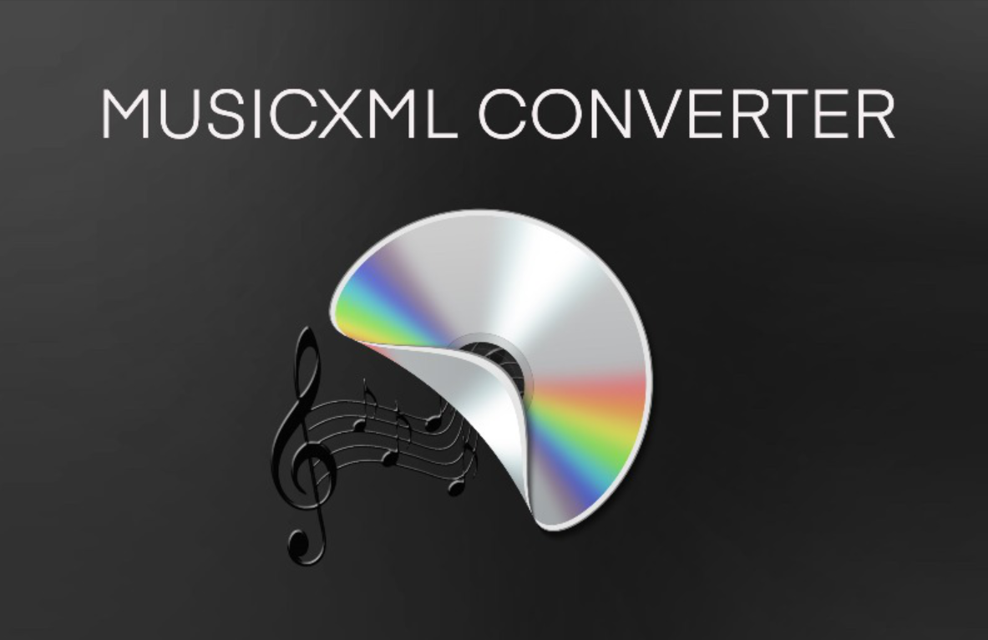

The intended user can start using the software by selecting the text-based tablature in their computer then the program will output the MusicXML. Before using the software it is necessary for the user to check that the text-based tablature is written in the standard musical notations to ensure that the program successfully converts the file.

This program is mainly aimed to help musicians or any individual who’s looking to translate their tablature file to a musicXML file which can easily be played or edited on various music software.

1. **System Requirement**

| Available Disk Space | 50 MB |
| --- | --- |
| RAM | 256MB |
| Java Version | Java 17 |
| Operating System | Windows, Linux, macOS, or any platform with Gradle |

1. **Installing TAB2XML using Gradle**

TAB2XML doesn’t have any specific restrictions and therefore can be run on any IDE of your choice. However, for the sake of demonstration, we only install and run the program via Eclipse. Below is the instruction on how to install it:

**Step 1**: Since this is a Gradle project, the **Gradle plugin** has to be installed on Eclipse before we run the program. To install the plugin, simply navigate to Help -> Eclipse Marketplace. After that, look for and install **Buildship Gradle Integration**. If you have already installed Gradle, you can skip this step.

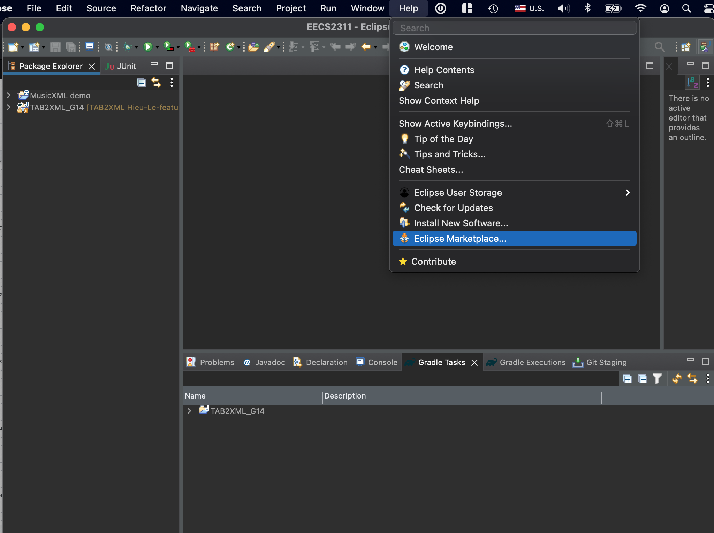

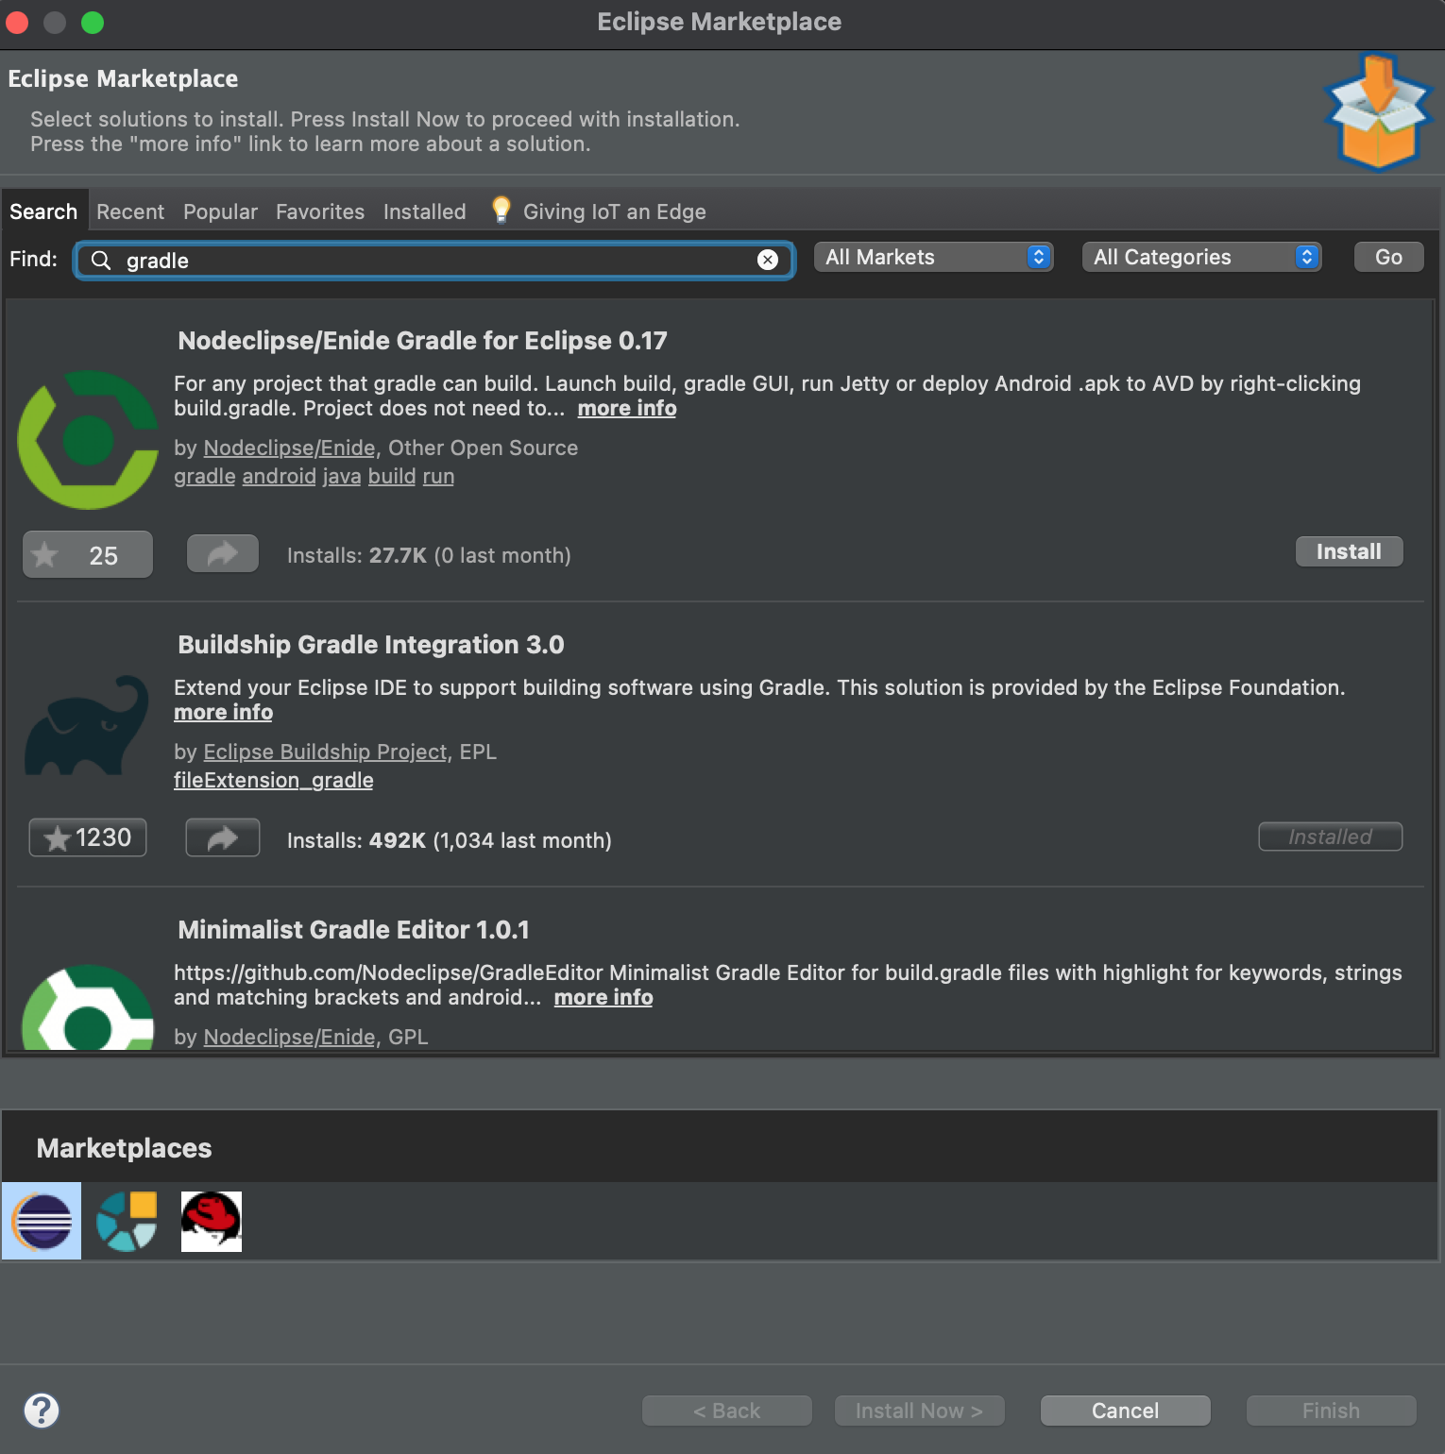

**Step 2:** After installing Gradle, we need to import the project into Eclipse. To do so, first access the project from Github via this link: <https://github.com/Baye0110/TAB2XML>. There, click the green **Code** button and **Download zip**. Now that you have a copy of the project on your local device, go to Eclipse then File -> Import -> Gradle -> Existing Gradle Project. Once you reach this window (image below), input the location where you downloaded the project into the **Project root directory** and press **Finish**.

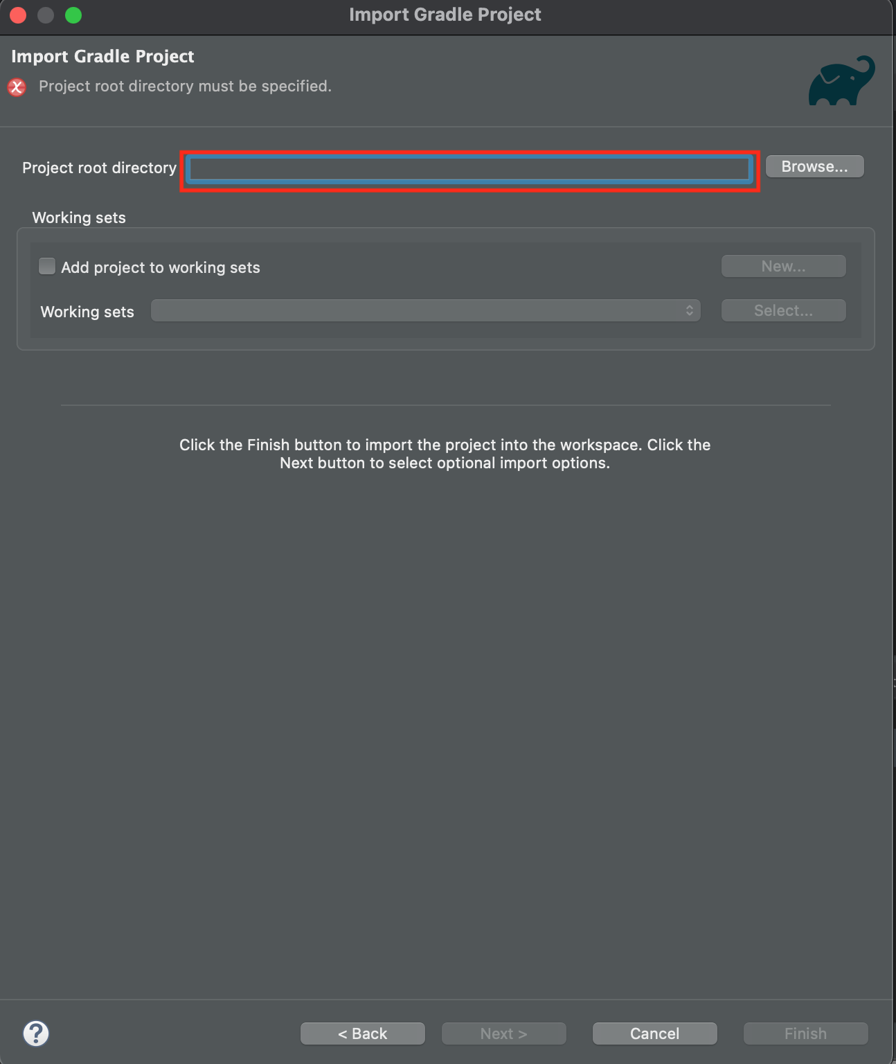

**Step 3:** Once the project finishes importing, look below to find the **Gradle tasks** tab. There you will find your newly imported program, press the arrow -> **build** folder -> build

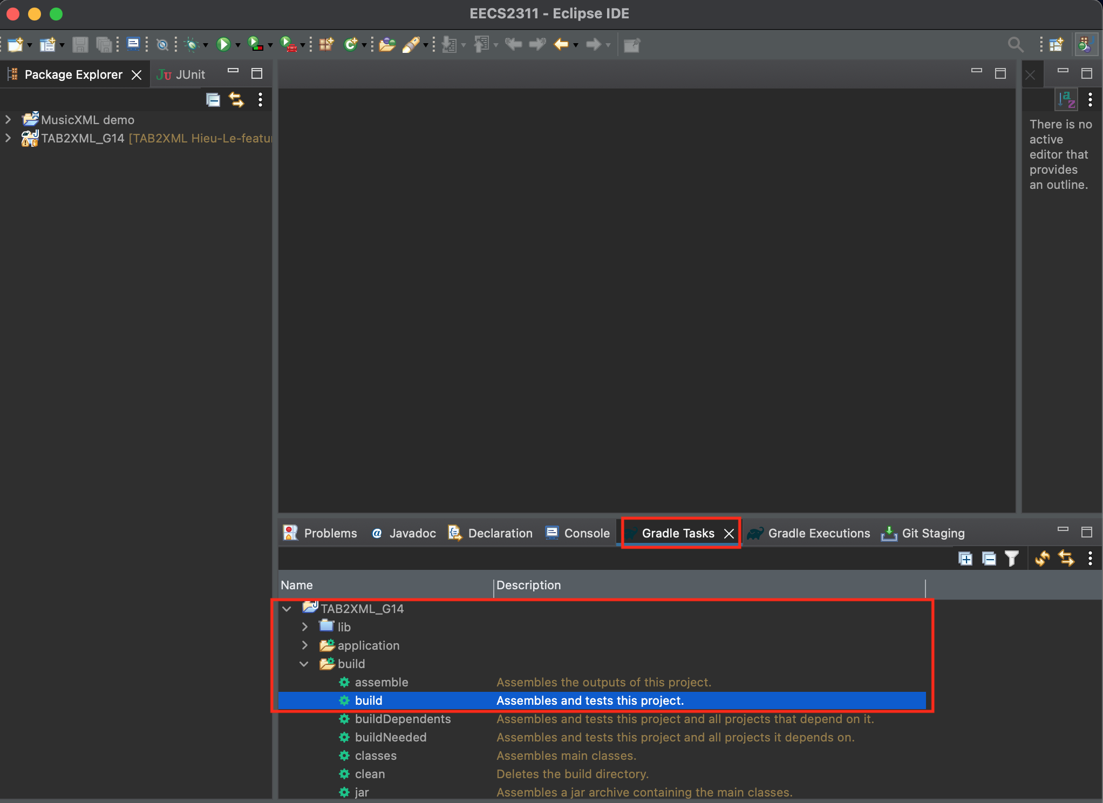

**Step 4:** Finally after the project finishes building, navigate to the **application** folder above, press the arrow -> run

1. **How to use TAB2XML**

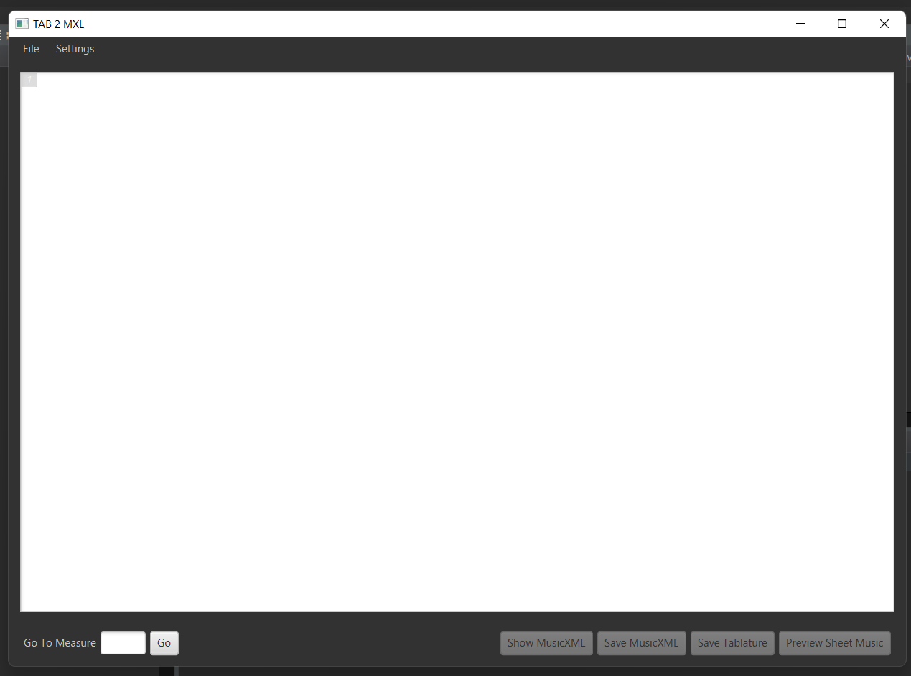

Run the application using Gradle Tasks. After running a Window called TAB 2 MXL pops up which gives the user multiple options (buttons) including Show Music XML, Save MusicXML, Save Tablature, Preview Sheet Music. The user should first upload their file using File -> Open. The user can also paste the tablature text directly into the text screen. After uploading, users can use the mentioned options as they desire. For terminating they can just simply close the application’s window.

**4.1 How to Use: [Preview Sheet Music]**

Upon selecting an appropriate tablature file or pasting the tablature directly into the application, simply click the “**Preview Sheet Music**” to view the sheet music. The sheet music will be displayed in a fixed window. In the case that the score is too long to fit within the height of the screen, the user can scroll through the sheet music to view certain measures at a time. To return to the initial screen the user can close this window, or click [**Exit**]

**4.2 How to Use: [Music Playback]**

While previewing the sheet music, the user can both play and pause the audio of the sheet music as they please using the two provided buttons [**Play**] and [**Pause**].

* [**Play**]: Triggers the music to play from the start of the song.
* [**Pause**]: Will cause the music to stop playing if it is already playing. In a paused state, this button will resume the playback from where it left off.



1. **Input Requirement**

Some sample tablature can be found in the project folder in the directory:

* TAB2XML/src/test/resources/system.
* Course wiki page: **Project > Useful Resources > Starter Examples**
* Online tablature .txt files, but make sure your file format must be the same as the resources provided by the professor.

**Note:** The version’s quality you prepared is not guaranteed which means it may not work properly.

**Note:** Our system currently only supposes Bass, Guitar tablature. Support for other instruments will be updated gradually.